6.1.2 Assessment Brief Coversheet
This brief relates to assessment using the following assessment technique
Assignment ☐ Project ☐ Learner Record ☐ Collection of Work ☒ Skills Demonstration ☐

Learner Name/ID:
Programme/ Centre: | Group/ Course Name/Code: |  | Major Award Code:
Kerry College – Clash Campus | Business Studies L5 |  | 5M2102
Module/ Component Code and Title: | Assessment Title/Weighting: |  | Learning Outcomes:
Applied Economics  5N1350 | Alternative to Exam_  Assignment 3 Theory Based  – 40% |  | LO1, 2, 3, 4, 5, 6, 7, 8, 9, 10, 11, 13, 14, 15, 16 & 17
Assessor Name: | Issue Date: |  | Submission Date & Time:
Margaret Burns | Tuesday 4th May, 2021 |  | Monday 10th May, 2021  - 6 pm
Integrated with other Assessments?  No ✔ Yes  If yes give details on the right |  | Assessor(2)
 |  | Module (2)
 |  | Learning Outcomes:

Coursework Brief – Detail/Requirements

Sections A
10 Short Answer Questions
Learners are required to answer all 10 questions (1mark per question)

Section B
6 Structured Questions
Learners are required to answer any 3 questions (10 marks per question)

Section A: Answer all of the following questions (1 mark each)
1. Outline the role of the European Central Bank (ECB). (1 mark)

2. Briefly explain two benefits of EMU (Economic and Monetary Union) for Ireland. (1 mark)

3. What is the role of the Central Bank of Ireland and one of its main responsibilities? (1 mark)
4. Explain the Law of Diminishing Marginal Utility. (1 mark)

5. What does the Law of Demand state? (1 mark)

6. The Supply function is represented as follows: Sy = f (Py, Pr, C, T, U, Cr., G).
Explain each element in the function. (1 mark)

7. Explain Elasticity. (1 mark)

8. Explain two factors that affect Price Elasticity of Demand (PED) (1 mark)
9. List two characteristics of Imperfect Competition. (1 mark)

10. Explain what is meant by Privatisation, and list one advantage of the privatisation of state assets. (1 mark)
(Total 10 Marks)

SECTION B: Answer any 3 of the following questions.

Question 1.

A. The table shows the level of National Income (Y), Consumption (C), Investment (I), Exports (X) and Imports (M) at the end of 2019 and 2020 (for the purpose of this question, you may ignore the government sector).

 | Y | C | I | X | M
2019 | ? | 80,000 | 20,000 | 90,000 | 90,000
2020 | 150,000 | 100,000 | 30,000 | 120,000 | ?

Calculate the following, showing all your workings:

(1) The value of National Income in 2019
(2) The value of Net Exports in 2020
(3) The level of Savings in the economy in 2020
(5 marks)

B. (1) Explain, with the aid of a diagram, the Circular Flow of Income for an open economy.
(3 marks)

(2) Outline how each of the following should affect the level of National Income in Ireland

- An increase in Irish Exports
- An increase in the level of savings (2 marks)
(10 marks)

Question 2.

“The World Trade Organisation (WTO) is the only international organisation dealing with the global rules of trade between nations.”
(1) Outline two economic benefits claimed for ‘free trade’. (2 marks)
(2) Outline three reasons why countries might choose to impose barriers to free trade.
(3 marks)
(3) What is the Law of Absolute Advantage? Give an example of a country that has one? (2marks)
(4) Explain three assumptions underlying the Law of Absolute Advantage. (3marks) (10 marks)

Question 3.
A. An economic system is the institutional means through which natural resources are used to satisfy human wants. There are three economic systems:
- Free Enterprise/Laissez Faire or Capitalism
- Centrally Planned/Command Economy (Communism)
- Mixed Economy (Central planned and private enterprise).
You are required to:
Discuss the characteristics of each economic system; give at least three for each with reference to Ownership of the Factors of Production, Government Interference, Decision Making etc. (6 marks)

B. Outline an advantage and a disadvantage of each type of economic system above. (4 marks) (10 marks)

Question 4.
A. A firm operating under conditions of Perfect Competition is a ‘price taker’.
(1) Explain the concept of being a ‘price taker’. (1 mark)

(2) Explain, with the aid of a labelled diagram, the equilibrium position of a firm in short run Perfect Competition. (3 marks)

B. With the aid of a labelled diagram(s), explain the impact which the entry of new firms would have on the Market/Industry and on the equilibrium position of this Firm.
(6 marks)
(10 marks)
Question 5.
A. In order to achieve its objectives the Government has many tools or policies at its disposal, e.g.
- Fiscal Policy
- Legislation
- Market Intervention
- Social Partnership
- Exchange Rate Policy
- Monetary Policy
Choose four from the above list and discuss how each policy can be used to achieve government objectives. (6 marks)

B. State and explain what you consider to be the three most important economic aims of the Irish Government.
(4 marks)
(10 marks)

Question 6.

A. (1) Distinguish between the short-run and the long-run production periods.
(2 marks)

(2) In the short-run firms may stay in the industry even if they are making a loss.
Explain. (1 marks)

B.

Units of Bread | Total Costs (€)
0 | 100
100 | 200
200 | 280
300 | 330
400 | 360
500 | 450
600 | 600
700 | 770

(1) Use the data in the table above to answer the following questions:

- What are the fixed costs of operating this bakery? Explain your answer.
(1 mark)
- What are the variable costs of producing 300 loaves of bread? (1 mark)
- What is the average cost of producing 400 loaves of bread? (1 mark)
- Using the data from the table, draw one graph showing the following:

- Total Costs (label the curve TC) (1 mark)
- Total Variable Costs (label the curve VC) (1 mark)
- Total Fixed Costs (label the curve FC). (1 mark)

- With reference to the graph you have drawn in part d) does the graph represent the short run or the long run? Outline a reason for your answer.

(1 mark)
(10 marks)

Evidence for this assessment technique may take the form of written, and or graphic evidence.

Submission Details
Your work must be submitted to your course teacher/ tutor/ instructor and on or before the due date.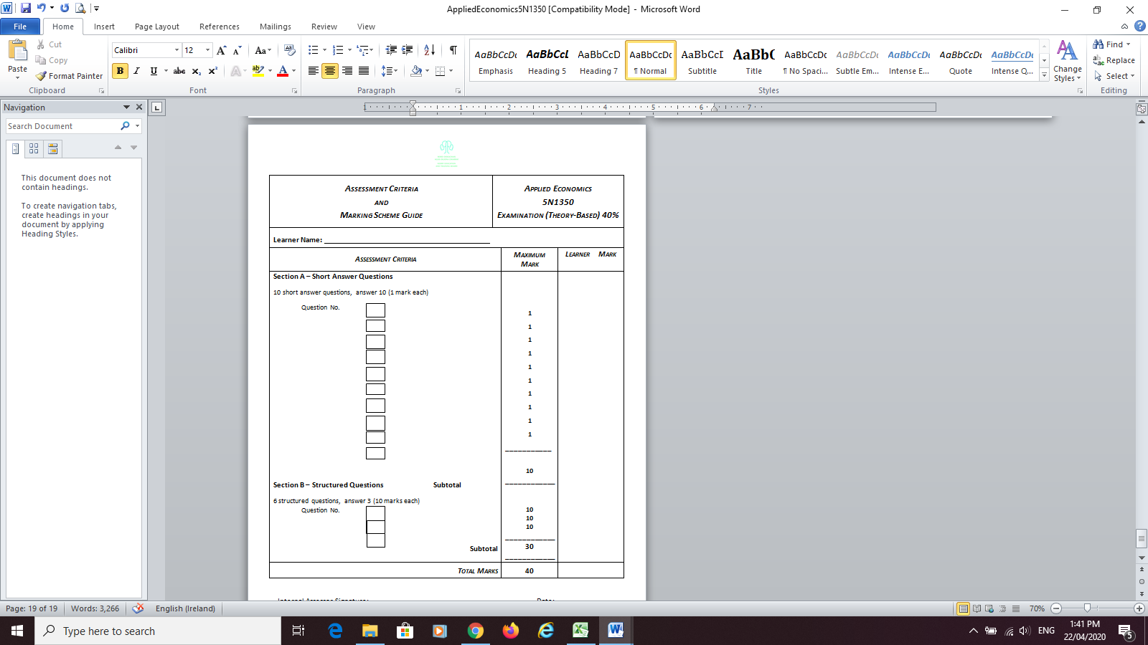

Page 1 of 2

6.1.2 Assessment Brief Coversheet
Please complete this and include it with your work when you are submitting it to your teacher/tutor/instructor for assessment

Declaration  I am signing this to confirm that: |  |  |  | TICK P
- This is my own work |  |  |  | x
- I understand that passing someone else’s work off as my own, without referring to it or getting their permission is called malpractice. |  |  |  | x
- I understand that if there is a doubt about this work being my own it can be investigated and if found to be malpractice I may not receive certification. |  |  |  | x
- I am aware that Kerry ETB has an Assessment Malpractice policy and an Assessment Deadline policy which applies to me. |  |  |  | x
Learner Signature |  | Date:

Dates Feedback
I received Feedback on this assessment:  Date / Ongoing | Where Evidence of Feedback is Found | Learner Signature | Teacher/Tutor/Instructor Signature
 | Via Microsoft Teams Spreadsheet |  | Margaret Burns

Details of evidence: Written ☐ Verbal ☐ Recorded ☐

Page 2 of 2

